Appendix I

Triassic at Chaohu, Anhui Province, South China
The South China Lower Triassic marine sequence was thoroughly studied in the past few decades, because of the exceptional vertebrate faunas preserved in many Lagerstätten intervals, as reviewed by Benton et al. (2013). The Lower Triassic sequence is well exposed at Pingdingshan-Majiashan in Chaohu, Anhui Province, South China (31.62° N, 117.82° E) (Fig. SI 1). It is a complete Induan to Olenekian succession composed of the Yinkeng Formation, Helongshan Formation and Nanlinghu Formation in ascending order. At the top of the Helongshan Formation, abundant Smithian nodules (calcareous concretions) yielding perfectly preserved fish fossils were found, while in the Upper Member of the Nanlinghu Formation (especially the base part) the abundant well-preserved and diverse Spathian marine reptile fossils were excavated (Sun et al. 2013; Tintori et al. 2014; Jiang et al. 2016). The Early Triassic sediments in this section were deposited in a deep-water (200 to 500 m) slope setting (Fig. SI 1) on the northern border of the Yangtze Platform where the eastern Tethyan and western Panthalassa were connected (Tong & Yin, 2002; Sun et al. 2009; Tong & Zhao, 2011). Cyclostratigraphic studies identified meter-scale stratigraphic packages interpreted to be shallowing-upward cycles (Tong & Yin, 2002; Sun et al. 2009).

.
Fig. SI 1 - Left: Simplified geological map of Chaohu, Anhui, South China Modified from (Tong & Zhao, 2011) (PN: Pingdingshan; ML: Majiashan; T₁y: Lower Triassic Yingkeng Formation; T₁h: Lower Triassic Helongshan Formation; T₁n¹, T₁n², T₁n³: Lower Triassic Nanlinghu Formation, the Lower, Middle and Upper Members). Right: Paleographic setting of Chaohu, Anhui.

The whole Lower Triassic sequence was measured in about 313.6 m thick, in ascending order described briefly as following:
The Yingkeng Formation is well exposed at Pingdingshan with a thickness of 83.76 m, overlying the Permian Dalong Formation and overlaid by the Helongshan Formation. It is composed of light grey, green, yellowish mudstone and shale intercalated with thin-bedded muddy limestone and nodular limestone. The Induan-Olenekian boundary was proposed to be at the base of Bed 24, defined by the first appearance of conodont Neospathodus waageni (Tong & Zhao, 2011), about 40 m above the base of Yingkeng Formation.

The Helongshan Formation is well exposed at Majiashan with a thickness of 21.24 m and represents a highly cyclic sedimentation of alternating pyrite-rich marl and bivalve wackestone. It is subdivided into two members: a) the Lower Member (9.34 m thick) is composed of yellowish grey-purple thin-bedded nodular limestone and calcareous mudstone, its upper part develops light grey medium-bedded muddy limestone; b) the Upper Member (11.9 m thick) mainly consists of grey thin-bedded limestone intercalated with yellowish green thin-bedded nodular limestone. The uppermost beds are about 2.83 m thick black shale and dark grey thin-bedded marls, in which the lower 1.43 m part yields very rich fossil nodules (calcareous concretions) containing abundant fishes, associated with abundant ammonoids and bivalves. The Smithian/Spathian boundary, defined by the first appearance of conodont Neospathodus pingdingshanensis is about 1.4 m below the top of the Helongshan Formation.

The Nanlinghu Formation is well exposed at Majiashan with a thickness of 208.60 m and can be subdivided into three members. The Lower Member of Nanlinghu Formation (40.29 m thick) is characterized by light grey, thick-bedded limestone. Its lower part mainly comprises grey-reddish, medium-bedded, nodular muddy limestone intercalated with dark grey limestone, while its upper part mainly comprises grey to dark grey, thick-bedded limestone intercalated with yellowish, medium and thin-bedded, nodular muddy limestone and calcareous mudstone.
The Middle Member of Nanlinghu Formation (68.61 m thick) consists of reddish, medium-thick-bedded, nodular limestone. Its lower part yields purple to reddish, thin to medium-bedded, nodular muddy limestone and marls intercalated with grey, thin to medium-bedded limestone. The middle part is composed of grey to dark grey, medium-thick-bedded limestone intercalated with purple reddish, greyish green, nodular muddy limestone and calcareous shell. The upper part mainly yields greyish green thin-medium-bedded nodular muddy limestone intercalated with mudstone and dark grey thin-bedded limestone.
The Upper Member of Nanlinghu Formation (76.48 m thick) consists of alternating dark grey thin-bedded marls and shells. The lower part of this member comprises dark grey, thin-bedded marls and muddy limestone intercalated with yellowish green calcareous shells, yielding abundant and well-preserved Triassic marine reptiles and fishes. The upper part is composed of dark grey to black, thin-bedded marls and limestone intercalated with bituminous shells and carbonaceous shells, the top beds yield chert nodules.

The Guanling Formation mainly comprises clastic rocks and carbonates. It is subdivided into two members: the Lower Member contains yellow-green fine sandstones, silty mudstones and mudstones intercalated with muddy dolomites interpreted to reflect a transition from restricted-evaporitic tidal flat to shallow marine facies, whereas the Upper Member comprises light-gray to dark- gray nodular micritic limestones, muddy limestones and cherty micritic limestones with bands of dolomites.
From the upper Guanling Formation, two Pelsonian (Anisian, Middle Triassic) marine vertebrate faunas were discovered, namely the Panxian Fauna and the Luoping Fauna, respectively.

The stratigraphic information regarding the intervals investigated for calcareous nannofossils (see range chart Fig. 2) are given below, from oldest to youngest. Nannofossil (sub)samples were taken from samples previously investigated for marine faunas and available at the Department of Earth Sciences of the University of Milan (Italy).

SMITHIAN: Lower Qinglong Formation at Longtan section (Nanjing, Jiangsu Province) (Fig. SI 2).
The detailed lithostratigraphy of the Longtan section is described by Liu et al. (2020) who performed a high-resolution conodont biostratigraphy providing a latest Smithian age.
Nannofossil sample: The MAST sample derives from a fish-bearing nodule collected from the upper part of the Lower Qinglong Formation.

Fig. SI 2 - Conodont distribution at the Longtan and Qingshan sections (South Majiashan, Chaohu County) after (Liu et al. 2020). The red oval indicates the stratigraphic position of the nodule investigated here for calcareous nannofossils.

SPATHIAN: Nanlinghu Formation outcropping in the Majiashan area. The Spathian interval was intensively investigated at the Majiashan Quarry east of Chaohu Lake (Anhui Province, South China) where a nearly complete succession of Early Triassic (upper part of the Yinkeng Formation) to early Middle Triassic (Dongmaanshan Formation) is exposed (Ji et al. 2021). Based on ammonoid biostratigraphy a middle Spathian age was derived (Ji et al. 2015). Astronomical cyclostratigraphy based on δ¹³C chemostratigraphy (Fu et al. 2016) provided a ca. 248.8 Ma for Bed 605 (Ji et al. 2021).
Nannofossil samples: 605 and 680 from the Middle Member and Upper Member, respectively, of the Nanlinghu Formation.

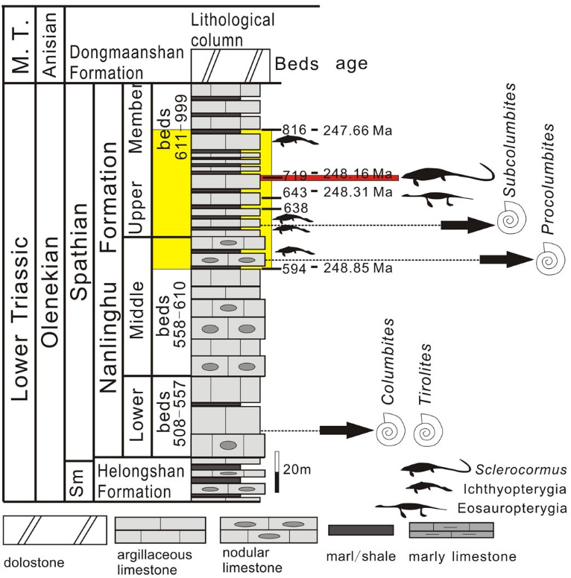

Fig. SI 3 - The stratigraphic column of Majiashan (M.T.: Middle Triassic; Sm: Smithian. From (Jiang et al. 2016). The yellow band indicates the interval of the 605 and 680 samples investigated for calcareous nannofossils.

ANISIAN: Upper Guanling Formation outcropping at Luoping in Yunnan Province (Fig. SI 4).
The Guanling Formation mainly comprises clastic rocks and carbonates. It is subdivided into two members, of which the lower member contains yellow-green ﬁne sandstones, silty mudstones and mudstones intercalated with muddy dolomites interpreted to reﬂect a transition from restricted-evaporitic tidal ﬂat to shallow marine facies, whereas the upper member comprises light-gray to dark-gray nodular micritic limestones, muddy limestones and cherty micritic limestones with bands of dolomites (Sun et al. 2016).
The Upper Member of the Guanling Formation was sampled at Xinmin (Panzhou, Guizhou) and at Xiaowa (Luoping, Yunnan) and dated as Pelsonian based on conodonts and ammonoids (Zhang et al. 2009). Benton et al. (2013) provided a thorough stratigraphic synthesis.
Nannofossil samples: C1, C3 and C4 from the Panxian Level; L2, L5 and L6 from the Luoping Level.

Fig. SI 4 - a) Geographic map and (b) Simpliﬁed lithostratigraphic log of the Triassic marine vertebrate faunas in Guizhou Province and adjacent area (Sun et al. 2016). Nannofossil samples were taken from the Panxian (C1, C3 and C4) and Luoping (L2, L5 and L6) levels.

LADINIAN: Zhuganpo Member of the Falang Formation outcropping near the village of Nimaigu (Wusha District). Calcareous nannofossils were investigated in samples previously studied for marine reptiles and fishes in the Nimaigu section, Wusha District (Xingyi, Guizhou Province) (Lu et al. 2018). The Nimaigu section is located at 25°09’52’’N, 104°47’18’’E at an altitude of about 1491 m. The studied interval, 48.5 m thick, (Layers 26 to 239 in Lu et al. 2018) corresponds to the Zhuganpo Member of the Falang Formation and was described in detail by Zou et al. (2015) (Fig. SI 5).
The Nimaigu section was dated as late Ladinian based on ammonoids Zou et al. (2015) and conodonts (Sun et al. 2016). A thorough regional stratigraphic synthesis provided a high-resolution biochronology of the Zhuganpo member corresponding to the Longobardian (late Ladinian) (Benton et al. 2013; Sun et al. 2016). Moreover, radiometric dating based on zircon U-Pb was achieved for tuff at the bottom of Layer 47, providing an age of 240.8 ± 1.8 Ma (Lu et al. 2018).
Nannofossil samples: 29b to 224

Fig. SI 5 - Location map of the Xingyi fossil locality and lithostratigraphy of the the Nimaigu section, Wusha District after Zou et al. (2015).

References
Benton M.J., Zhang Q., Hub S., Chen Z., Wen W., Liu J., Huang J., Zhou C., Xie T., Tong J. & Choo B. (2013) - Exceptional vertebrate biotas from the Triassic of China, and the expansion of marine ecosystems after the Permo-Triassic mass extinction. Earth-Science Reviews, 125: 199-243.
Fu W.-L., Jiang D.-Y., Montañez I.P., Meyers S.R., Motani R. & Tintori A. (2016) - Eccentricity and obliquity paced carbon cycling in the Early Triassic and implications for post-extinction ecosystem recovery. Scientific Reports, 6: 27793.
Ji C., Tintori A., Jiang D., Motani R. & Confortini F. (2021) - New Thylacocephala (Crustacea) assemblage from the Spathian (Lower Triassic) of Majiashan (Chaohu, Anhui Province, South China). Journal of Paleontology, 95: 305-319.
Ji C., Zhang C., Jiang D., Bucher H., Motani R. & Tintori A. (2015) - Ammonoid age control of the Early Triassic reptiles from Chaohu (South China). Palaeoworld, 24: 277-282.
Jiang D.-Y., Motani R., Huang J.-D., Tintori A., Hu Y.-C., Rieppel O., Fraser N.C., Ji C., Kelley N. P., Fu W.-L. & Zhang R. (2016) - A large aberrant stem ichthyosauriform indicating early rise and demise of ichthyosauromorphs in the wake of the end-Permian extinction. Scientific Reports, 6: 26232.
Liu S., Sun Z., Ji C., Zhou M. & Jiang D. (2020) - Conodont bistratigraphy and age of the Early Triassic fish-gearing-nodule levels from Nanjing and Jurong, Jiangsu Province, South China. Journal of Earth Science, 31: 9-22.
Lu H., Jiang D.-Y., Motani R., Ni P.-G., Sun Z.-Y., Tintori A., Xiao S.-Z., Zhou M., Ji C. & Fu W.-L. (2018) - Middle Triassic Xingyi Fauna: showing turnover of marine reptiles from coastal to oceanic environments. Palaeoworld, 27: 107-116.
Sun Z., Hounslow M. W., Pei J., Zhao L., Tong J. & Ogg J.G. (2009) - Magnetostratigraphy of the Lower Triassic beds from Chaohu (China) and its implications for the Induan–Olenekian stage boundary. Earth and Planetary Science Letters, 279: 350-361.
Sun Z., Jiang D., Li C. & Hao W. (2016) - Integrated biochronology for Triassic marine vertebrate faunas of Guizhou province, South China. Journal of Asian Earth Sciences, 118: 101-110.
Sun Z.-Y., Tintori A., Jiang D.-Y. & Motani R. (2013) - A new Perleididae from the Spathian (Olenekian, Early Triassic) of Chaohu, Anhui Province, China. Rivista Italiana di Paleontologia e Stratigrafia, 119: 275-285.
Tintori A., Huang J.D., Jiang D.-Y., Sun Z.-Y., Motani R. & Chen G. (2014) - A new Saurichthys (Actinopterygii) from the Spathian (Early Triassic) of Chaohu (Anhui Province, China). Rivista Italiana di Paleontologia e Stratigrafia, 120: 157-164.
Tong J. & Yin H. (2002) - The Lower Triassic of South China. Journal of Asian Earth Sciences, 20: 803-815.
Tong J. & Zhao L. (2011) - Lower Triassic and Induan-Olenekian Boundary in Chaohu, Anhui Province, South China. Acta Geologica Sinica, 85: 399-407.
Zhang Q.Y., Zhou C.Y., Lü T., Xie T., Lou X.Y., Liu W., Sun Y.Y., Huang J.Y. & Zhao L.S. (2009) - A conodont-based Middle Triassic age assignment for the Luoping Biota of Yunnan, China. Science in China Series D: Earth Sciences, 52: 1673-1678.
Zou X., Balini M., Jiang D.-Y., Tintori A., Sun Z.-Y. & Sun Y.-L. (2015) - Ammonoids from the Zhuganpo member of the Falang Formation at Nimaigu and their relevance for dating the Xingyi fossil-Lagerstätte (Late Ladinian, Guizhou, China). Rivista Italiana di Paleontologia e Stratigrafia, 121: 135-161.

